

**Emergency Kit**

**ISO 9650-1 SOLAS B Life Raft (£1603.20)**

Life raft, a last resort survival kit to be only used if the boat is not safe stay on. Cases include fire and sinking.

**Grab Bag (£30)**

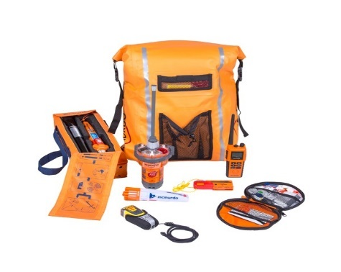

A Bag to take with you on the life raft. Includes things like passport, some spare cash, EPIRB, GPS, Flares, Lights etc.

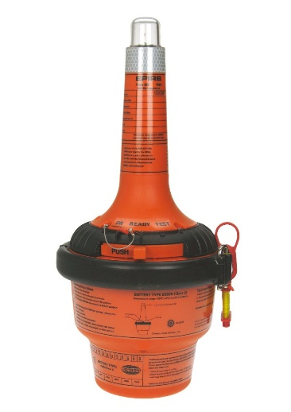 **EPIRB (£510)**

Emergency Position Indicating Radio beacon. A device to alert search and rescue for emergencies at sea. Sends a 48-hour continuous signal. One for grab bag and one for boat.



**Emergency Kit**

**Orange Smoking Floating Flare (£29.95)**

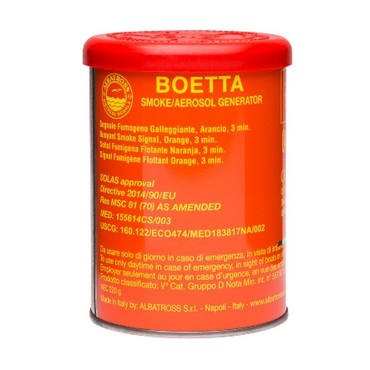

Floating Flare to keep in Grab bag for the life raft, so you can be found by search and rescue vessels. Daytime use only.

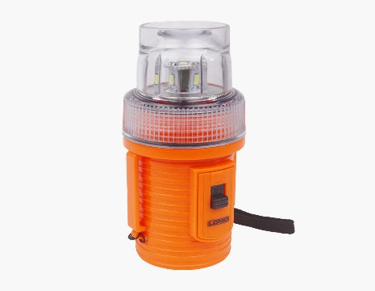 **Strobe Flashing Light (£15)**

A strobe light to keep in Grab bag for the life raft. So, you can be easily seen in the dark by search and rescue vessel.

**Handheld GPS (£134.40)** 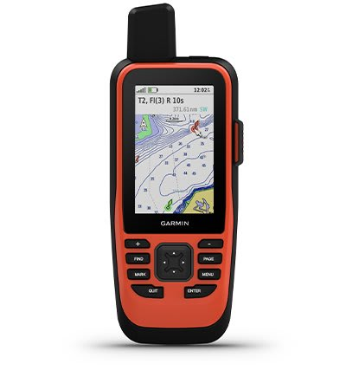

Handheld GPS. Provides your position for search and rescue vessels and useful for navigation. One needed for Grab Bag and one for boat use.



**Emergency Kit**

**Breakable Light Sticks (£24.80)**

Light sticks for Grab bag and to provide a luminous source for 12 hours without any electronics.

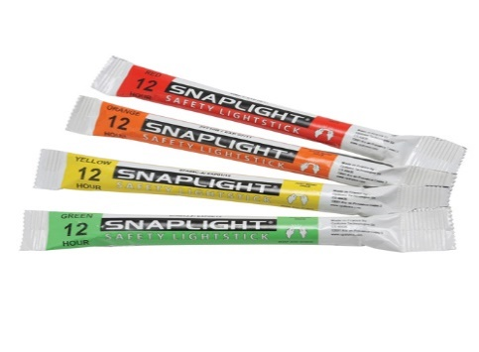

**Safety Kit**

**Life Jacket (£114)**

A life jacket with 150N of Buoyancy and crotch straps. Useful while rowing normally and needed for emergencies.

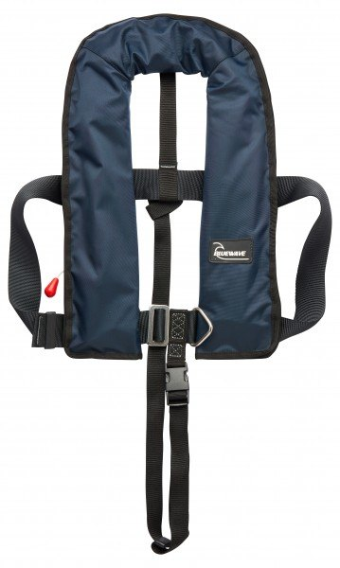

**Life Jacket Re-Arming Kit (£21.60)**

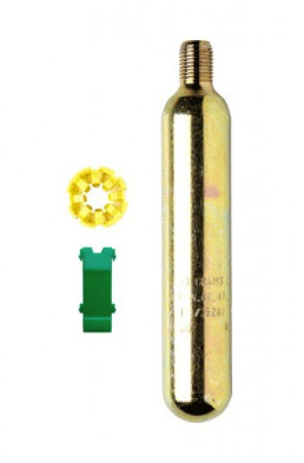

A rearming kit to replace the gas canister inside the life jacket if it runs out



**Safety Kit**

**3 Hook Safety Harness (£91.60)**

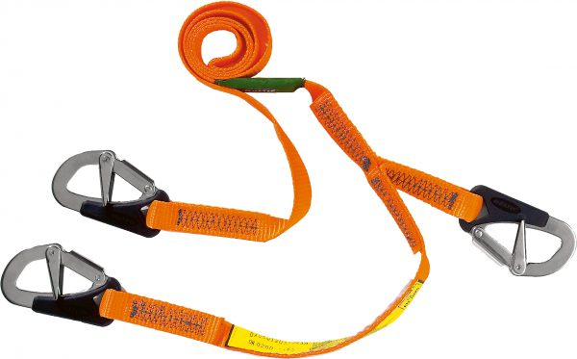

A crucial piece of kit to keep you alive by being clipped to the boat in the event of capsize.

**Waterproof Survival Suit (£234)**

A survival suit to keep you warm and prevent hyperthermia. Useful for winter training in UK and need for emergencies in the Atlantic Ocean.

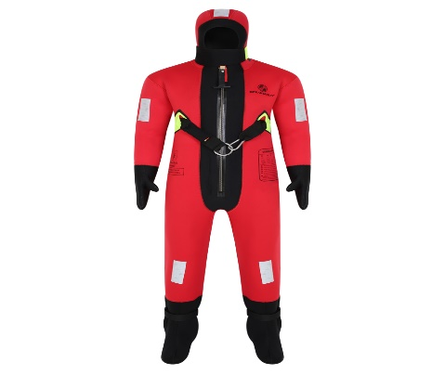

**Flare Pack (£372.32)** 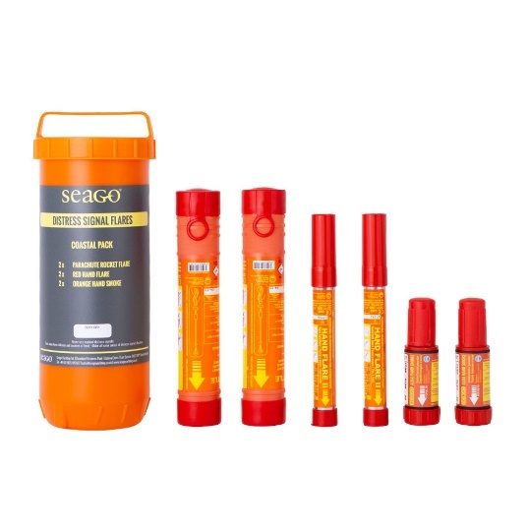

A large flare pack, mixture of red and green flares for signalling towards vessels if radio communications are not effective.



**Safety Kit**

**Daylight Signalling Mirror (£11.40)**

Used for signalling aircraft and ships during the day as part of the emergency SOLAS life raft kit.

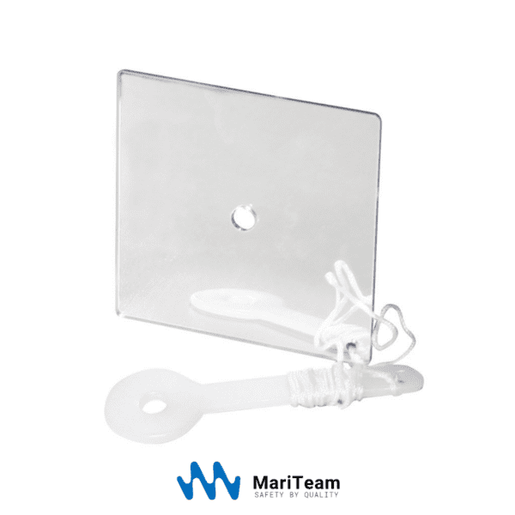

**Safety Markings (£54)**

Safety markings to be put inside both cabins and on the outside the shell. These are to label the port and starboard side if boat capsizes.

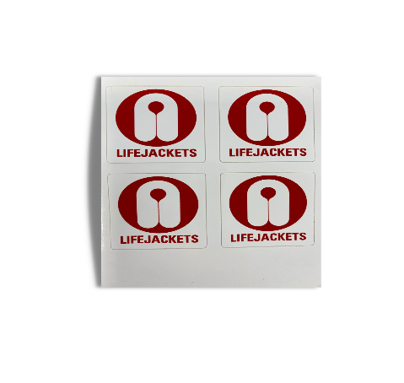

**SOLAS Reflective Tape (£54)**

Improves visibility at sea, especially at night for both normal rowing and emergencies.

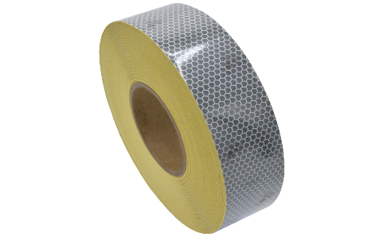



**Safety Kit**

**Blunt Deck Knife (£84)**

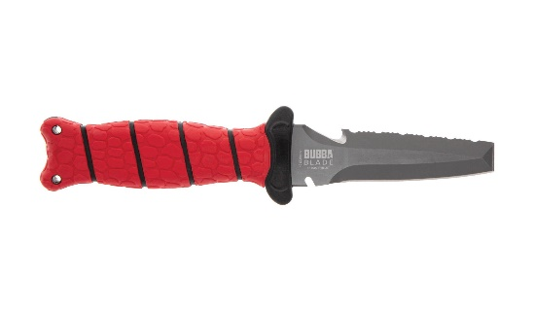

A knife for cutting rope. It is blunt ended for safety purposes such as poking holes in things.

**Handheld VHF Radio (£243.60)**

Handheld VHF useful for communicating without having to go inside the cabin if you need to contact a vessel immediately or shore-based station.

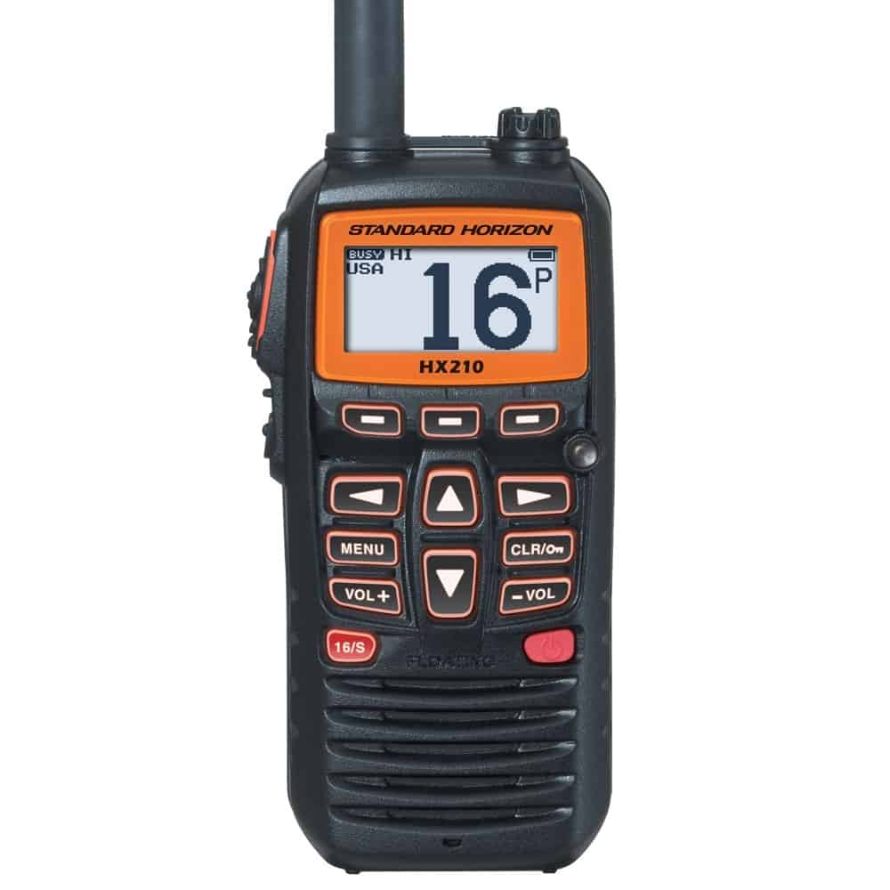

**PLB (£324)** 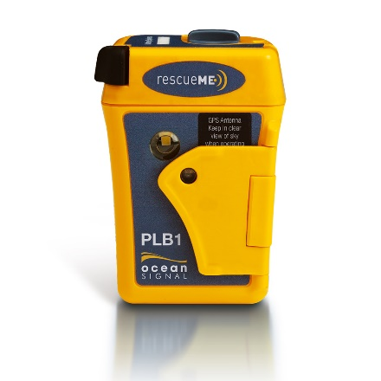

A Personal Locator Beacon. A small device that is always on person for vessels and aircraft to find you in emergencies.

**Essential Kit**

**15 L Water Container (£24)**

One container for emergency if water makers breakdown. Also, have one always filled with water for drinking and eating.

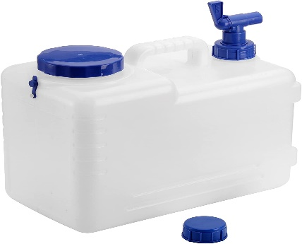

**Spare Rudder (£1440)**

A spare rudder in case the main breaks. Required for steering and for staying on course with the autohelm.

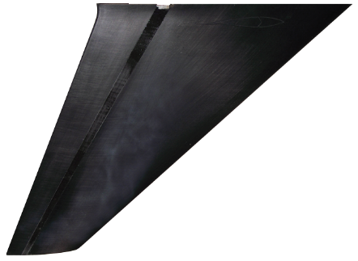

**Spare Tiller Arm (£384)**

Acts as lever to turn the rudder. A spare one in case the main one breaks.

****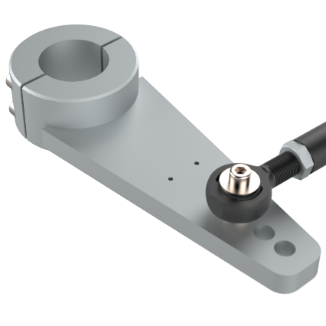



**Essential Kit**

**Pair of Oars (£960)**

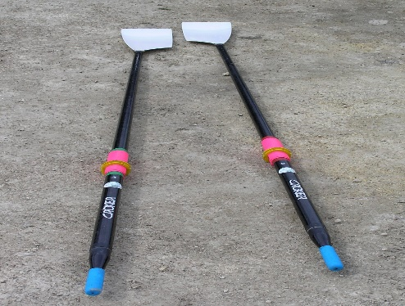

Oars needed to power the boat. One spare set needed and one set must be new.

**Oar Retainer Lines (£16.80)**

Retaining lines so that oars are attached to the boat and do not get lost in rough seas.

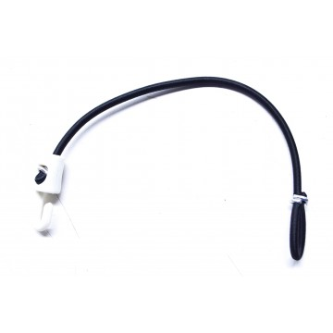

**Handheld Compass (£84)** 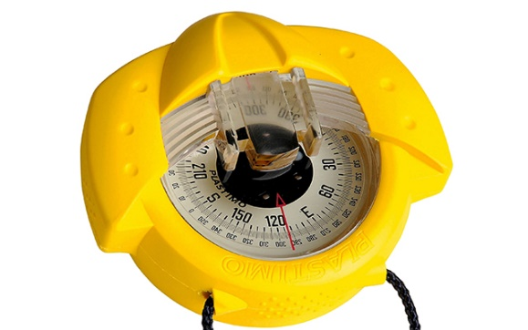

Handheld compass. Useful for keeping along a bearing. Handy for checking if you are on a collision course without vessels and other hazards.

**Essential Kit**

**JetBoil Cooker x2 (£372)**

A cooker crucial for heating water to cook food.

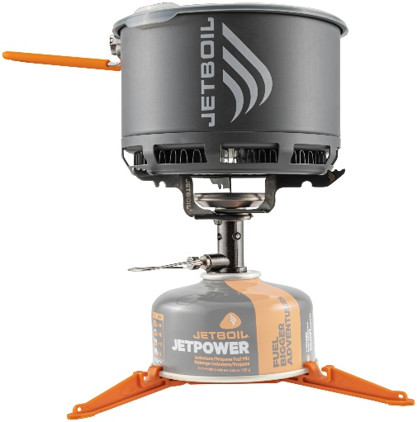

**Jet Boil Fuel (£16.80)**

Enough fuel for a solo crossing (450g).

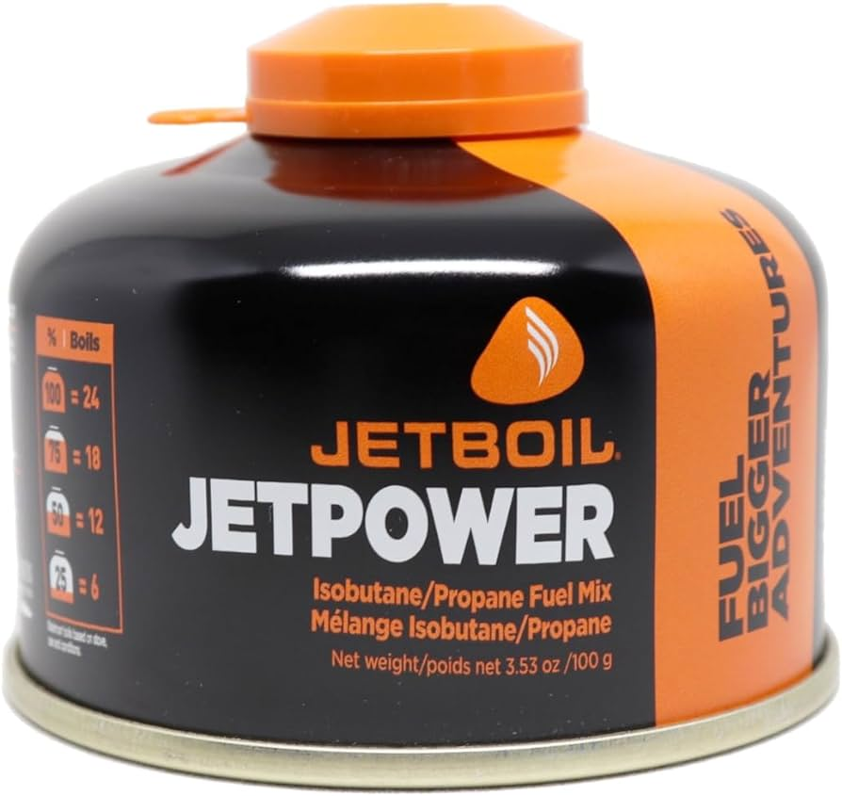

**Waterproof and wind**

**Resistant Matches (£13.20)**

****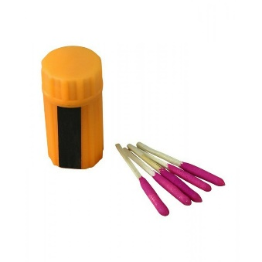

Waterproof and wind resistance army matches to light jet boil.

**Essential Kit**

**Buckets x3 (£50.40)**

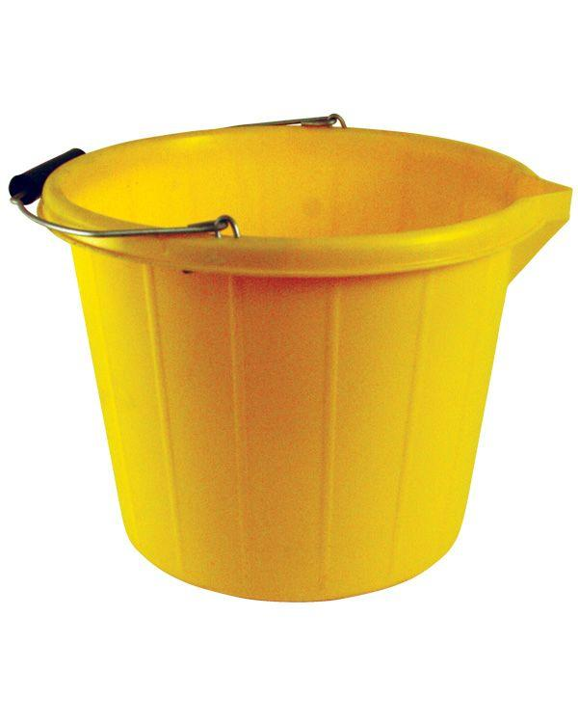

3 Buckets. One for washing in, one for general toilet use, one spare. All must have lanyards through them, so attached to boat.

**Stirrup Pump (£36)**

To pump water out from any locker in the boat.

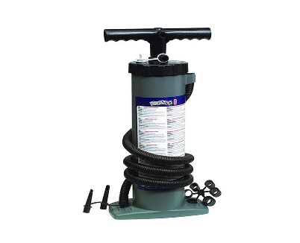

**Para-anchor (£1128.00)** 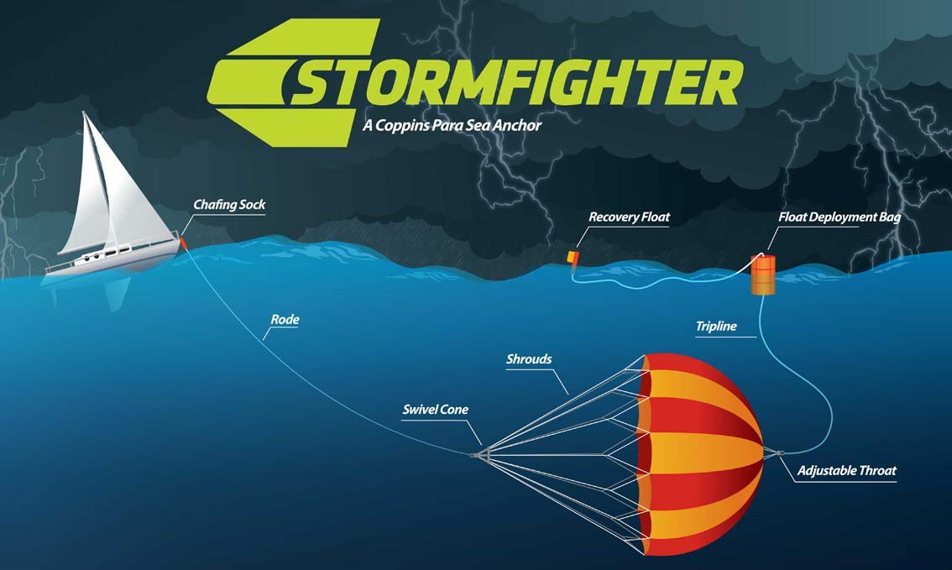

Highly useful for slowing you down when you are being blown in the wrong direction and minimises progress loss.



**Essential Kit**

**Fenders and Mooring Lines (£228)**

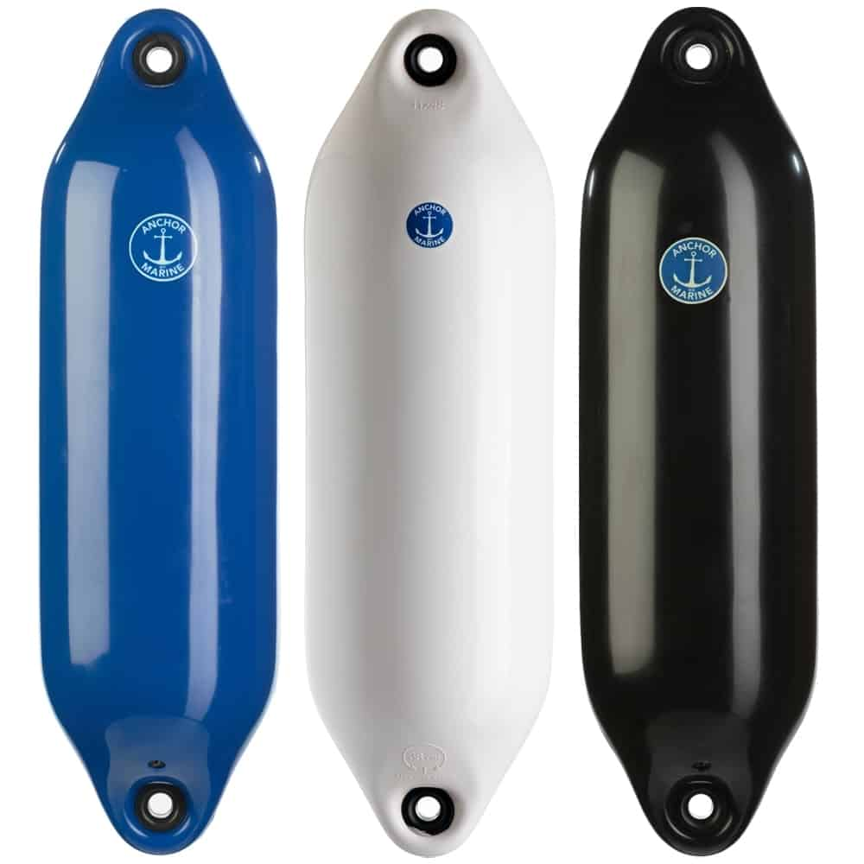

Required for Mooring at Marinas, such as at La Gomera and in the UK. Protects boat from damage from the pontoon or other boats.

**Drogue x2 (£86.40)**

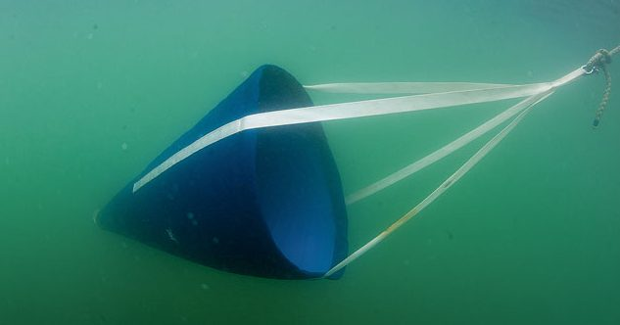

Required in stormy conditions, but you going too fast in the right direction and helps with stability.

**Anchor (£153.82)**

****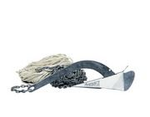

Needed to keep relatively stationary off UK coastal waters and to stop yourself crashing into the reefs in Antigua.

**Essential Kit**

**Foul Weather Jacket (£168)**

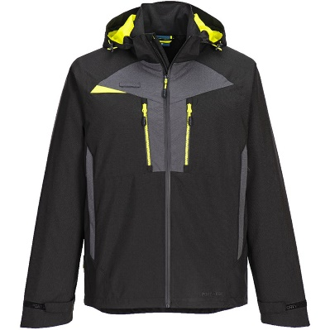

Foul weather kit that has 20000mm rainfall waterproofing and is breathable.

**Foul Weather Bottoms (£64.80)**

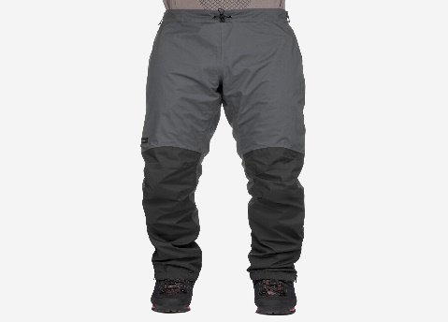

Foul Weather kit that has 15000mm rainfall waterproofing and is breathable.

**Fog Horn (£7.20)** 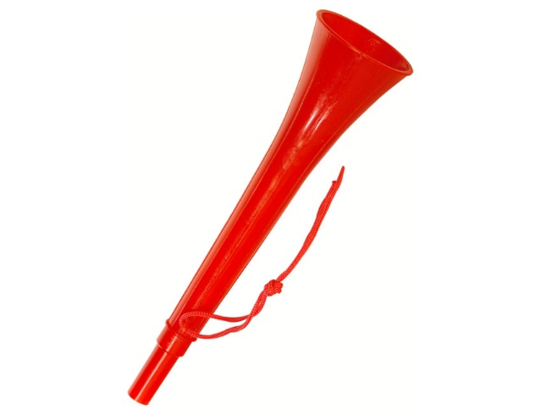

Alerting other vessels of your presence in foggy conditions.



**Essential Kit**

**Sunglasses x2 (£20)**

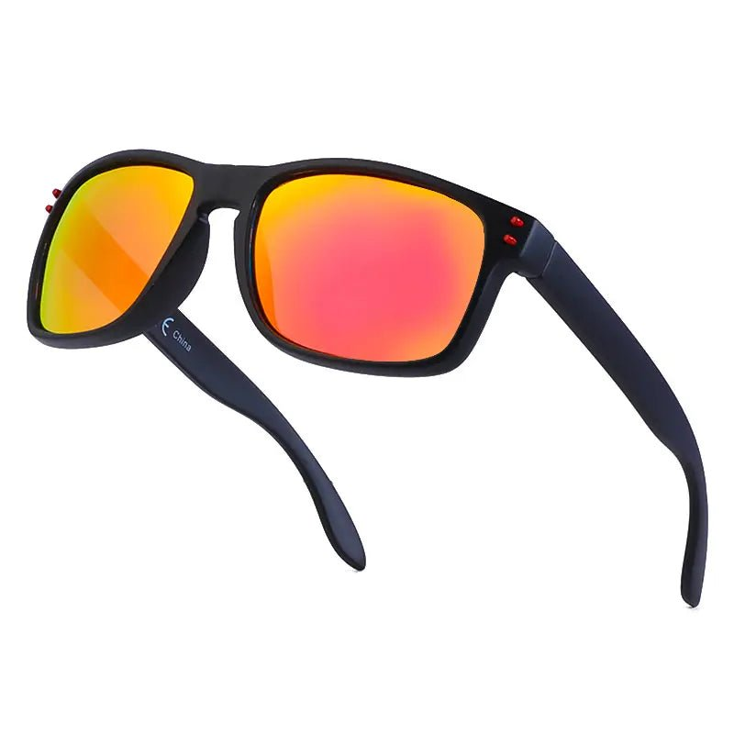

Sunglasses with UVA and UVB protection.

**Sunhats x2 (£20)**

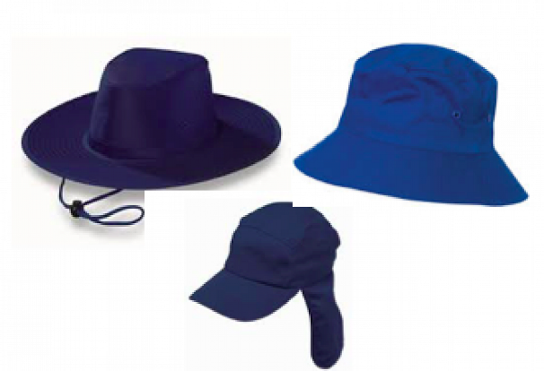

One must have protection for covering the back of the neck.

**Handheld Water maker (£2310.00)**

****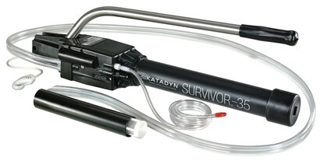

Converts seawater into drinkable water. Only needed when you have no power for the electronic watermaker.